|  |  |
| --- | --- |
|  | **FPT ACADEMY INTERNATIONAL**  **FPT – APTECH COMPUTER EDUCATION** |

**Centre Name: FAT2-HCM**

**Address: 590 Cach Mang Thang 8, District 3, Ho Chi Minh City, Viet Nam.**

🙢★🙠

**Auto Ancillaries Limited**

**User Guide**

|  |  |  |
| --- | --- | --- |
| **Supervisor:** | Mr. Hoang Duc Quang | |
| **Semester:** | 3 | |
| **Batch No:** | T1.2109.M1 | |
| **Group No:** | 6 | |
| **Team member:** | **Full name** | **Roll No.** |
| 1. | Tran Cong Thinh | Student1331708 |
| 2. | Tong Nguyen Thai An | Student1331707 |
| 3. | Huynh Ngoc Thai | Student1317113 |

**Month**: Dec **Year**: 2022

# Work Process

1. **User (Front-end)**

User can use system for:

* Before login:
* View Product
* View Category
* View Comment
* About Us
* Contact
* FAQ
* Register
* Login
* Search
* After login:
* View Product
* View Register Recipe
* View Cart
* Feedback
* About Us
* Contact
* View My Orders
* View Bill
* Post Comment

1. **Admin (Back-end)**

Admin must login first to manage system

* Logout
* User manage:
* View user list
* Reset password
* Active User
* Category manage:
* View category list
* Add new category
* Update category
* Delete category
* Product manage:
* View product list
* Filter product by Category
* Add new product
* Detail product
* Update product
* Delete product
* Comment manage:
* View comment list
* Order manage:
* View Order list
* Detail Order

# GUI DESIGN

## Homepage

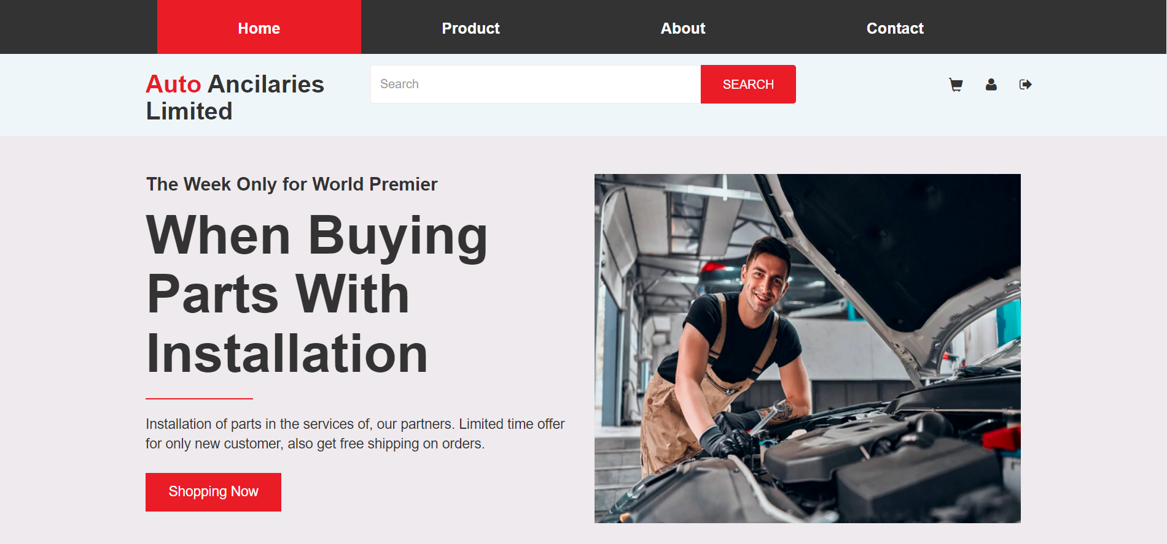

|  |  |  |  |  |  |  |
| --- | --- | --- | --- | --- | --- | --- |
| **No** | **Name** | **Type** | **Validation** | **Event** | **Description** | **Status** |
| 1 | Navigation Bar | Hyperlink |  | Click | Choose and go to pages | Enable |
| 2 | Log In / Register | Button |  | Click | Click to go to Log in/ Register page | Enable |
| 3 | Slider | Hyperlink |  | Click | Click to go to Product page | Enable |
| 4 | Category | Hyperlink |  | Click | Filter product by Category | Enable |
| 5 | Poster | Hyperlink |  | Click | Click to go to Product page | Enable |
| 6 | New / Popular product | Hyperlink |  | Click | New and most popular products | Enable |

## Productpage

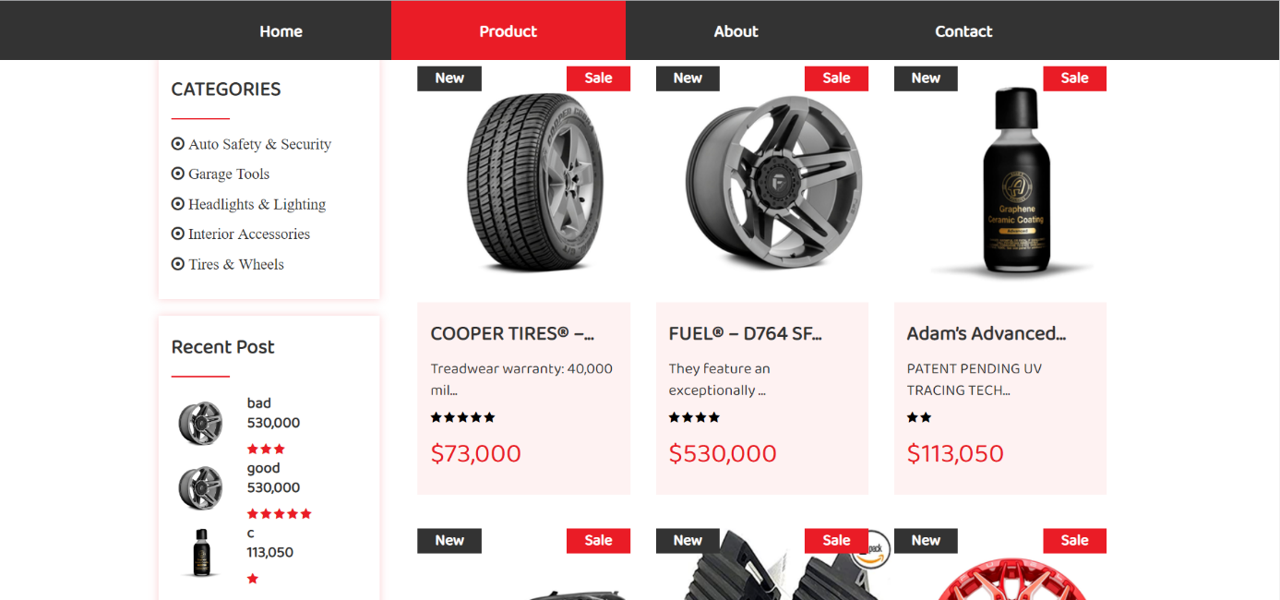

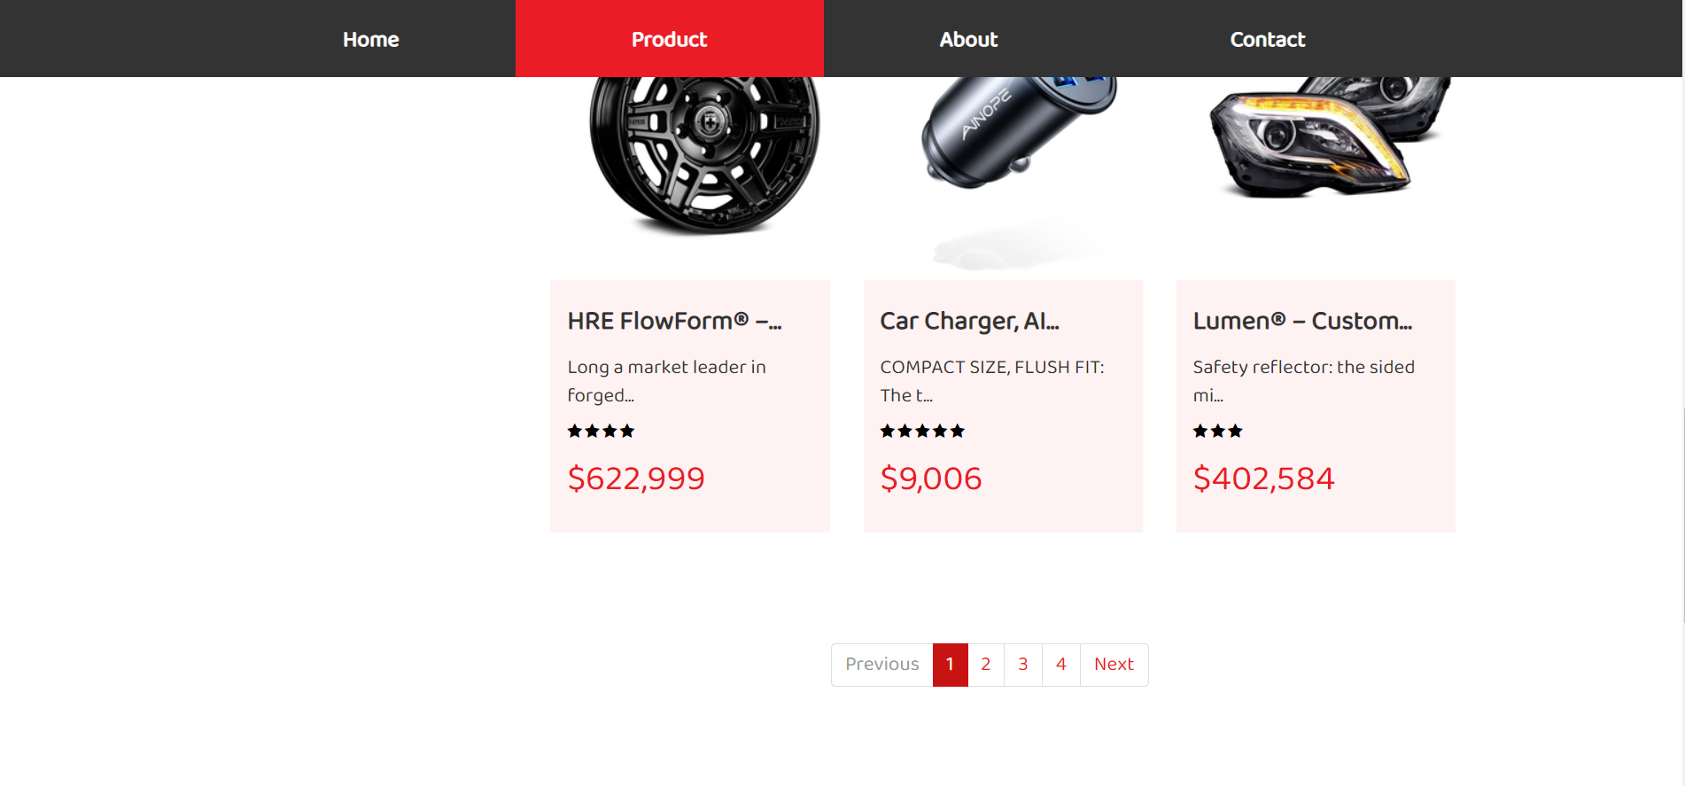

|  |  |  |  |  |  |  |
| --- | --- | --- | --- | --- | --- | --- |
| **No** | **Name** | **Type** | **Validation** | **Event** | **Description** | **Status** |
| 1 | Product | Hyperlink |  | Click | Choose to go to detail page | Enable |
| 2 | Recent post | Hyperlink |  | Click | Choose to go to detail page | Enable |
| 3 | Search | Get |  | Submit | Search any product | Enable |
| 4 | Category | Hyperlink |  | Click | Filter product by Category | Enable |
| 5 | Pagination | Button |  | Click | Click to pagination | Enable |

## Detailpage

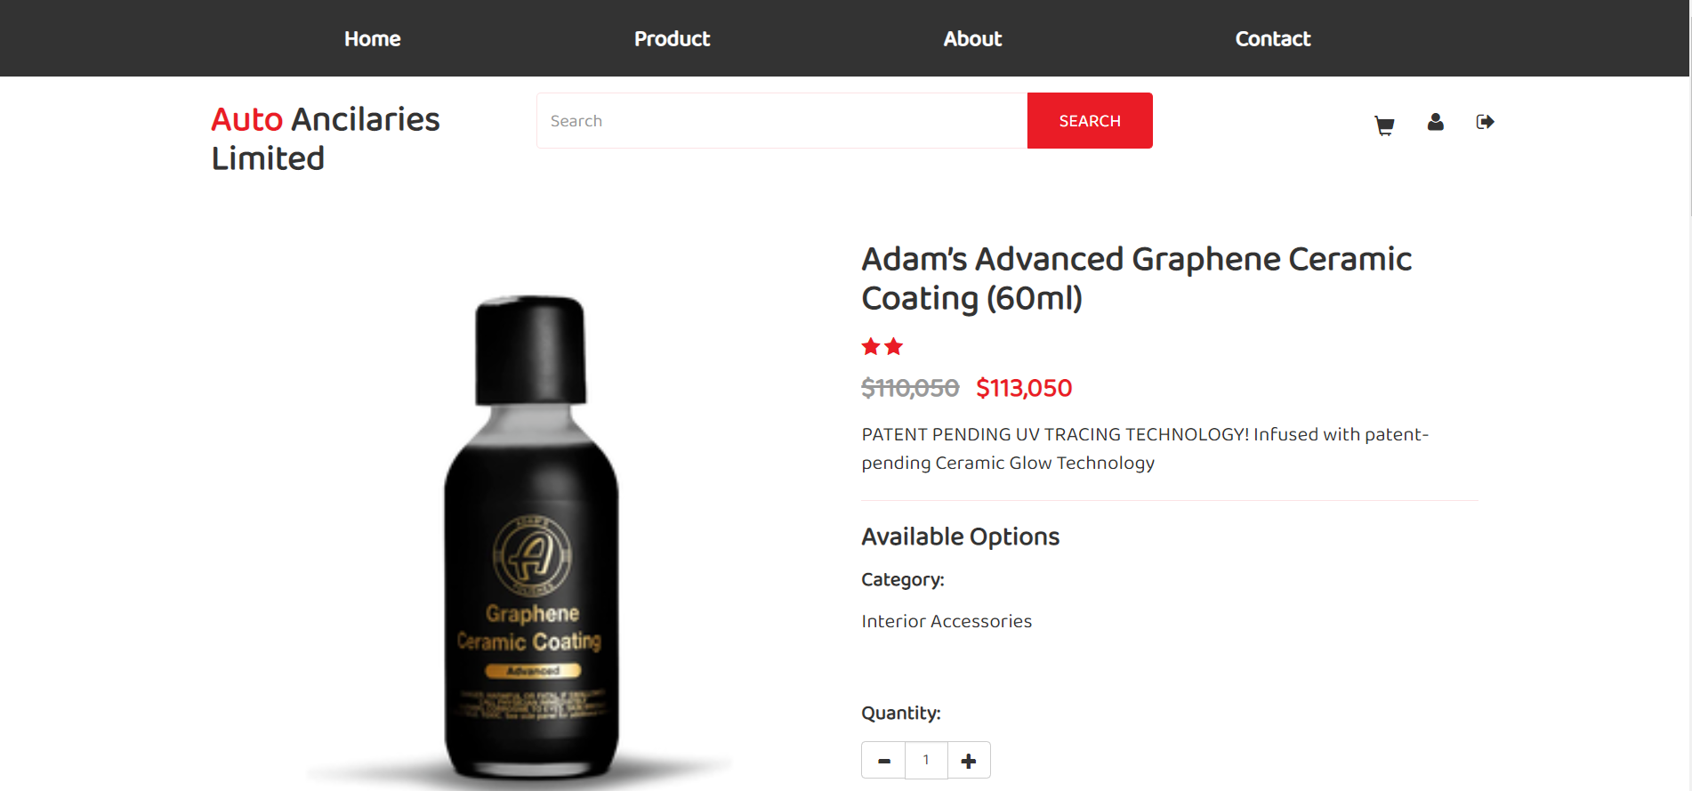

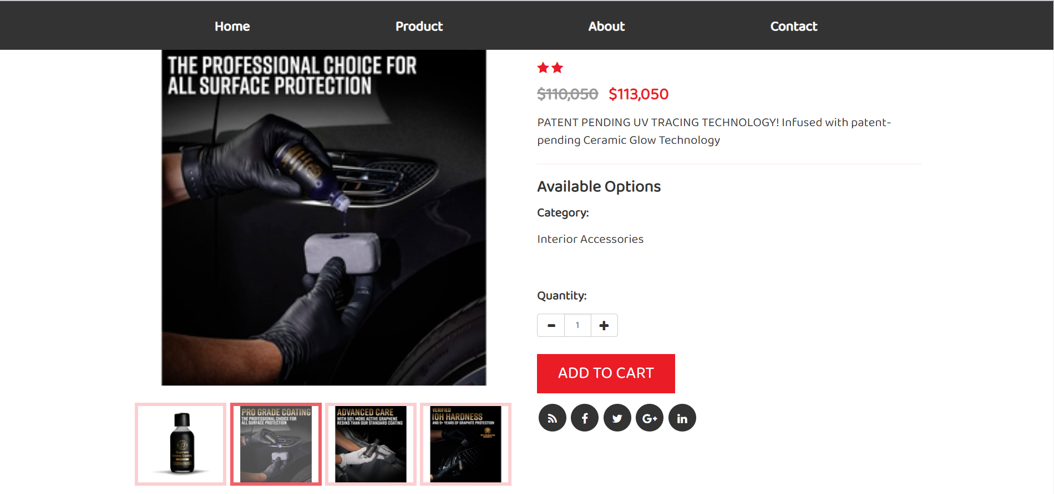

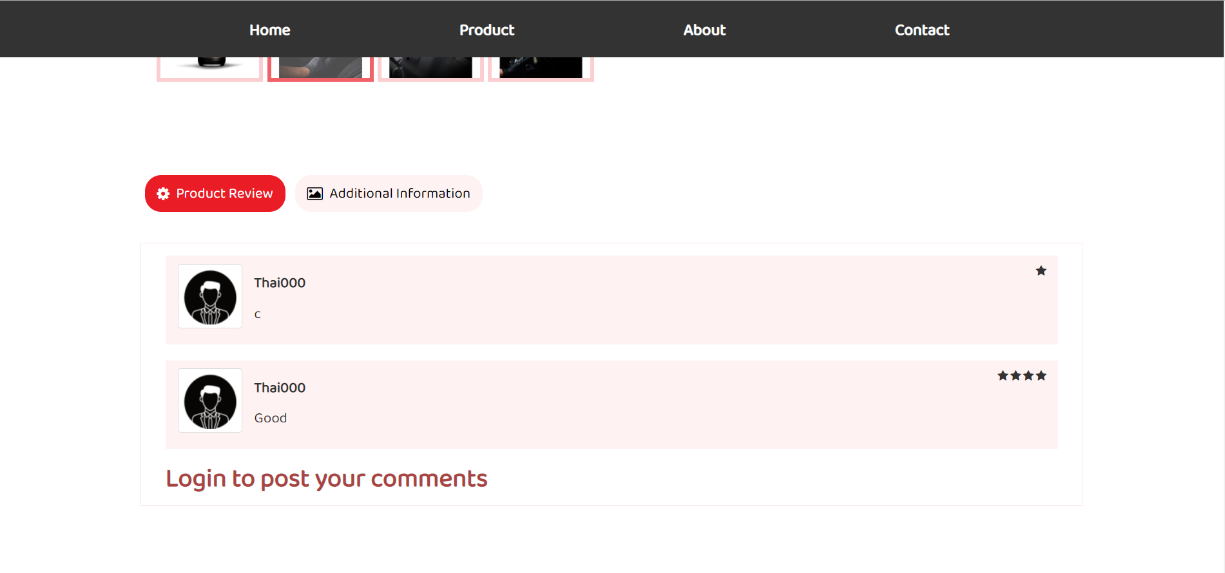

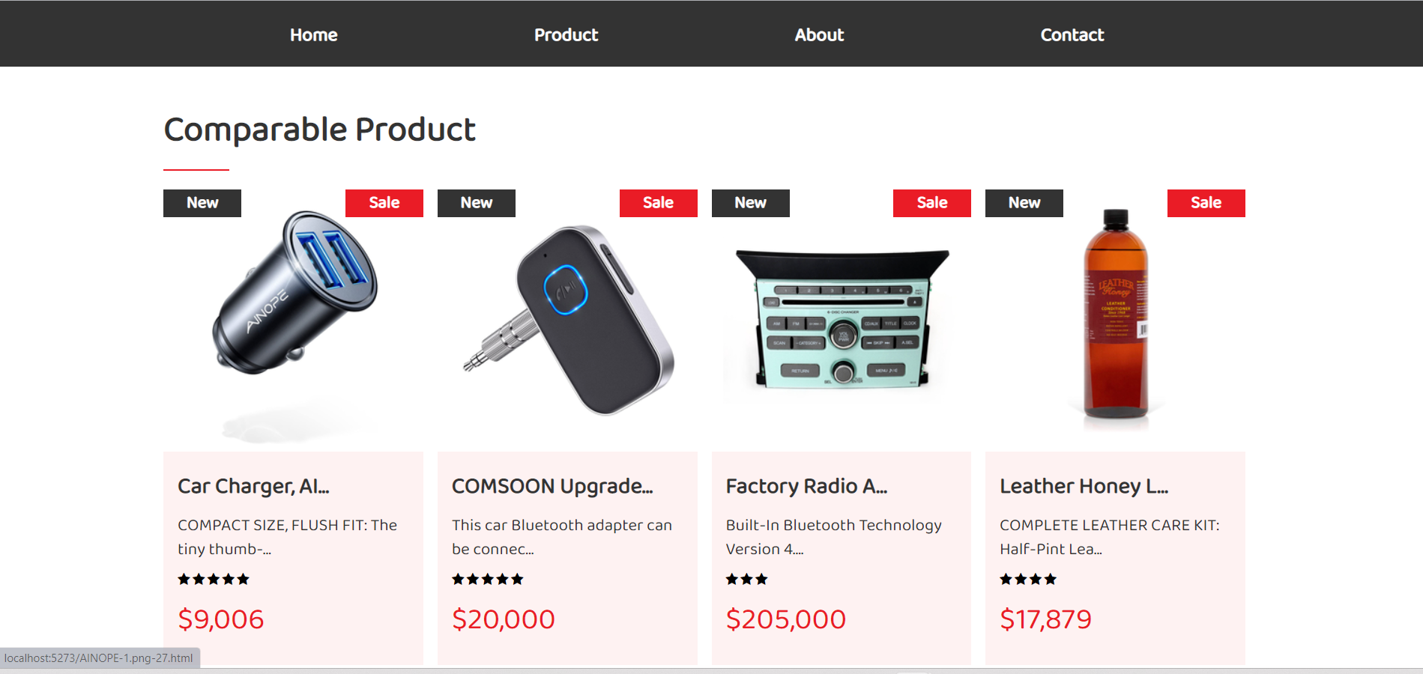

|  |  |  |  |  |  |  |
| --- | --- | --- | --- | --- | --- | --- |
| **No** | **Name** | **Type** | **Validation** | **Event** | **Description** | **Status** |
| 1 | Product detail |  |  |  | Product detail: Name, Price, Rate, Description, Image,.. |  |
| 2 | Add to cart | Hyperlink |  | Click | Choose to go to cart page | Enable |
| 3 | Comment | Post |  | Submit | Customer comment product and rating | Enable |
| 4 | Comparable Product | Hyperlink |  | Click | Comparable Product | Enable |

## Aboutpage

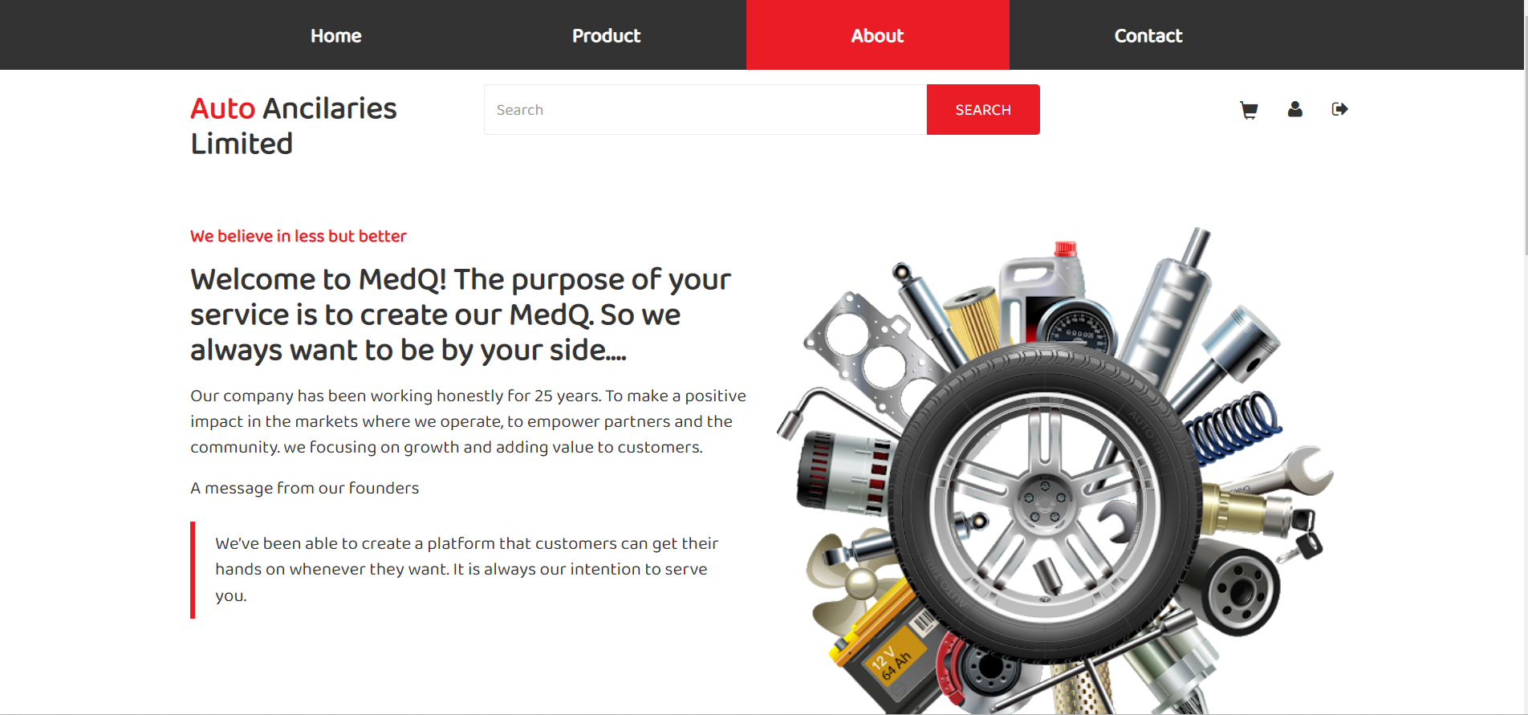

|  |  |  |  |  |  |  |
| --- | --- | --- | --- | --- | --- | --- |
| **No** | **Name** | **Type** | **Validation** | **Event** | **Description** | **Status** |
| 1 | About |  |  |  | Our information |  |

## Contactpage

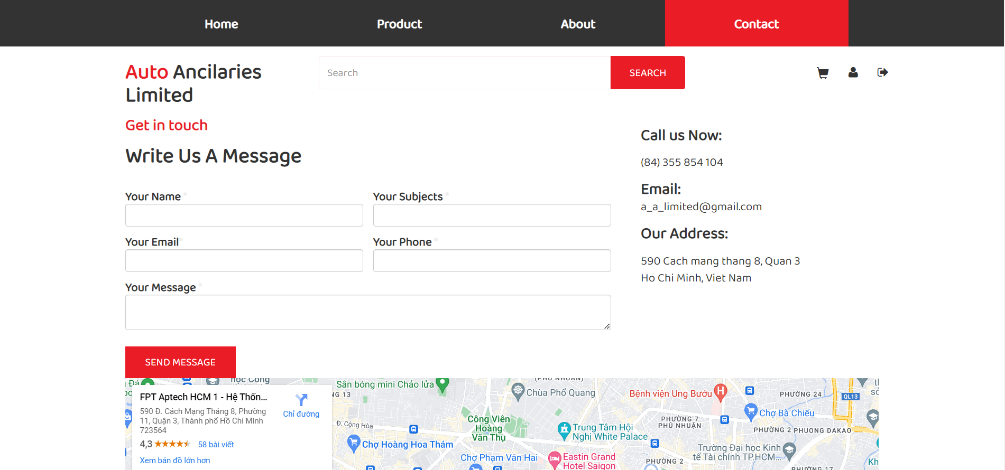

|  |  |  |  |  |  |  |
| --- | --- | --- | --- | --- | --- | --- |
| **No** | **Name** | **Type** | **Validation** | **Event** | **Description** | **Status** |
| 1 | Contact |  |  |  | Contact us |  |

## Login/Register

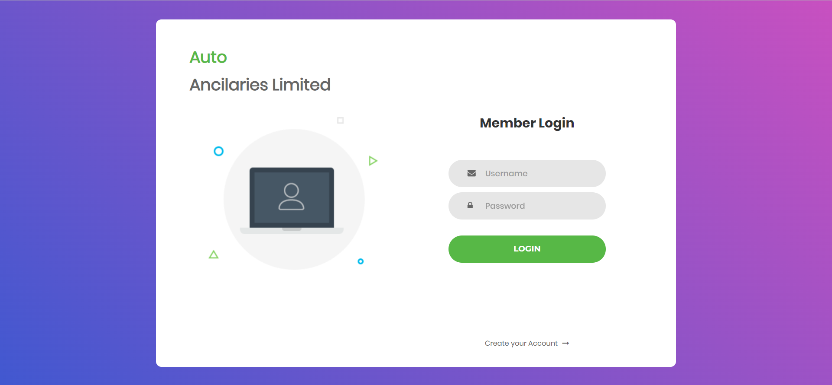

|  |  |  |  |  |  |  |
| --- | --- | --- | --- | --- | --- | --- |
| **No** | **Name** | **Type** | **Validation** | **Event** | **Description** | **Status** |
| 1 | Username | Input | Required |  | Input Username | Enable |
| 2 | Password | Input | Required |  | Input Password | Enable |
| 3 | Login | Buttion |  | Click | Login | Enable |
| 4 | Create your account | Link |  | Click | Click to go to Register Page | Enable |

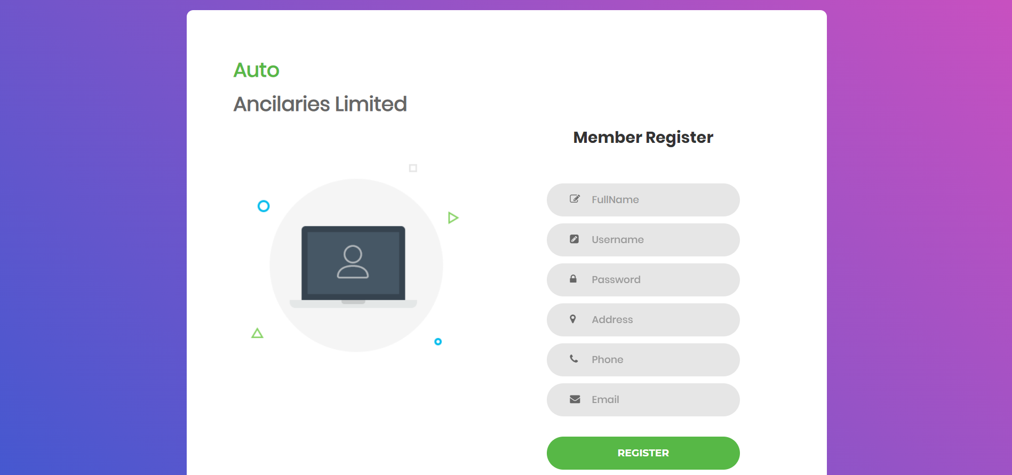

|  |  |  |  |  |  |  |
| --- | --- | --- | --- | --- | --- | --- |
| **No** | **Name** | **Type** | **Validation** | **Event** | **Description** | **Status** |
| 1 | Fullname | Input | Required |  | Input Fullname | Enable |
| 2 | Username | Input | Required |  | Input Username | Enable |
| 3 | Password | Input | Required |  | Input Password | Enable |
| 4 | Address | Input | Required |  | Input Address | Enable |
| 5 | Phone | Input | Required |  | Input Phone | Enable |
| 6 | Email | Input | Required |  | Input Email | Enable |
| 7 | Register | Button |  | Click | Register to go to Login page | Enable |

## Admin manage List Product

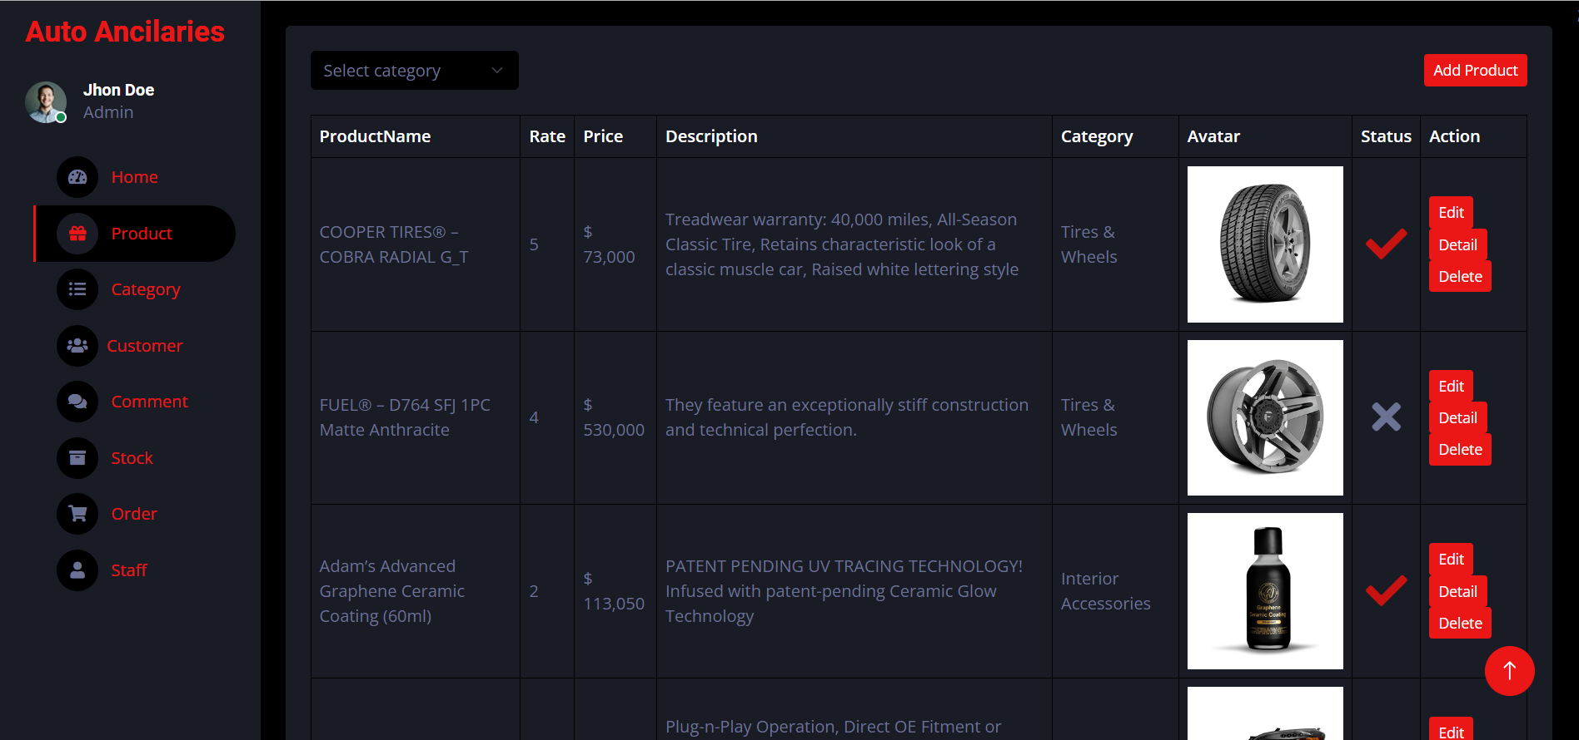

|  |  |  |  |  |  |  |
| --- | --- | --- | --- | --- | --- | --- |
| **No** | **Name** | **Type** | **Validation** | **Event** | **Description** | **Status** |
| 1 | Sidebar | Hyperlink |  |  | Choose and go to page | Enable |
| 2 | Filter | Dropdown |  |  | Filter product by category | Enable |
| 3 | Add | Button |  |  | Add new product | Enable |
| 4 | Edit | Button |  |  | Edit product | Enable |
| 5 | Detail | Button |  |  | Detail product | Enable |
| 6 | Delete | Button |  |  | Delete product | Enable |
| 7 | Pagination | Hyperlink |  | Click | Click to pagination | Enable |

## Admin manage Add Product

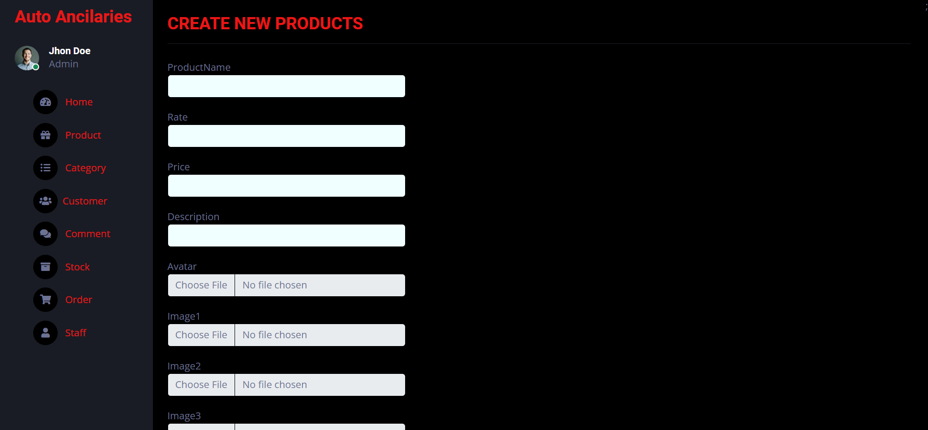

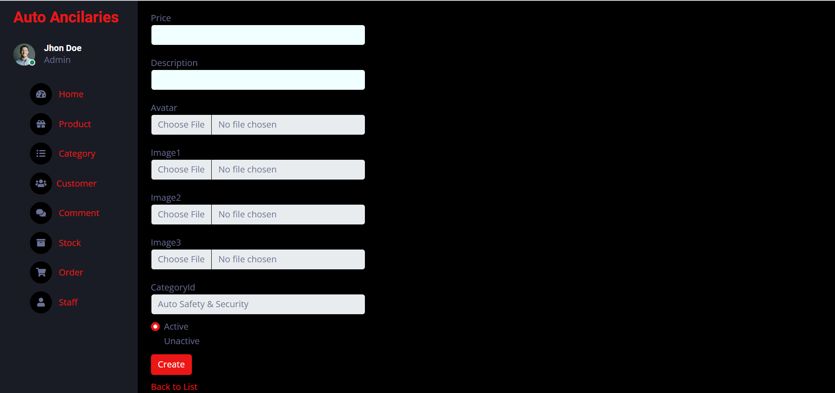

|  |  |  |  |  |  |  |
| --- | --- | --- | --- | --- | --- | --- |
| **No** | **Name** | **Type** | **Validation** | **Event** | **Description** | **Status** |
| 1 | ProductName | Input | Required |  | Insert product name | Enable |
| 2 | Rate | Input | Required |  | Insert product rate | Enable |
| 3 | Price | Input | Required |  | Insert product price | Enable |
| 4 | Description | Input | Required |  | Insert product description | Enable |
| 5 | Avatar | File | Required |  | Upload product avatar | Enable |
| 6 | Image1 | File | Required |  | Upload product image1 | Enable |
| 7 | Image2 | File | Required |  | Upload product image2 | Enable |
| 8 | Image3 | File | Required |  | Upload product image3 | Enable |
| 9 | CategoryId | Select | Required |  | Select category | Enable |
| 10 | Active or Unactive | Radio | Required |  | Choose active or unactive | Enable |
| 11 | Create | Button |  |  | Submit create product | Enable |
| 12 | Back to list | Hyperlink |  | Click | Return list product page | Enable |

## Admin manage edit Product

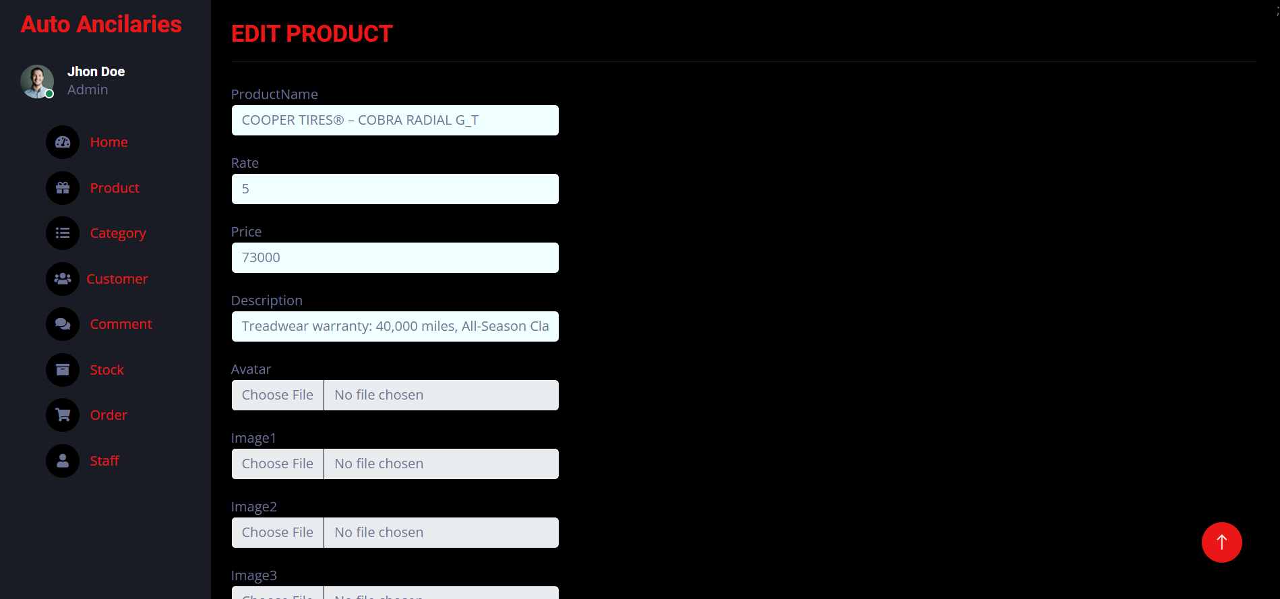

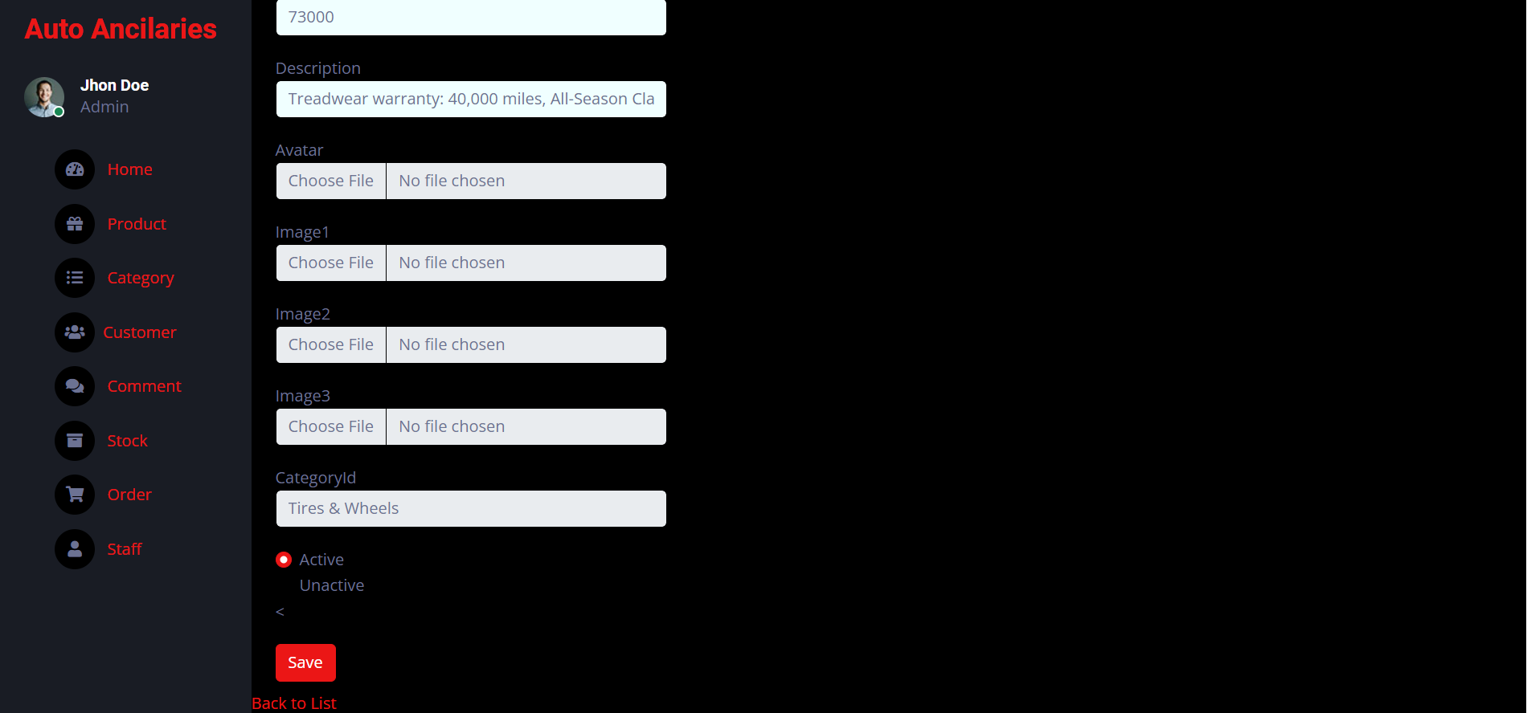

|  |  |  |  |  |  |  |
| --- | --- | --- | --- | --- | --- | --- |
| **No** | **Name** | **Type** | **Validation** | **Event** | **Description** | **Status** |
| 1 | ProductName | Input | Required |  | Edit product name | Enable |
| 2 | Rate | Input | Required |  | Edit product rate | Enable |
| 3 | Price | Input | Required |  | Edit product price | Enable |
| 4 | Description | Input | Required |  | Edit product description | Enable |
| 5 | Avatar | File | Required |  | Edit product avatar | Enable |
| 6 | Image1 | File | Required |  | Edit product image1 | Enable |
| 7 | Image2 | File | Required |  | Edit product image2 | Enable |
| 8 | Image3 | File | Required |  | Edit product image3 | Enable |
| 9 | CategoryId | Select | Required |  | Edit category | Enable |
| 10 | Active or Unactive | Radio | Required |  | Edit active or unactive | Enable |
| 11 | Save | Button |  |  | Edit product | Enable |
| 12 | Back to list | Hyperlink |  | Click | Return list product page | Enable |

## Admin manage detail Product

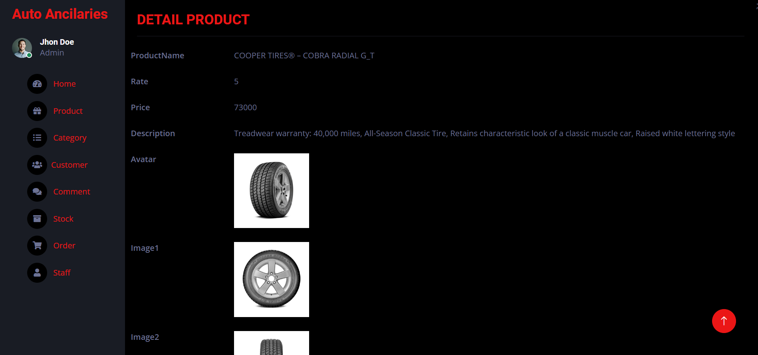

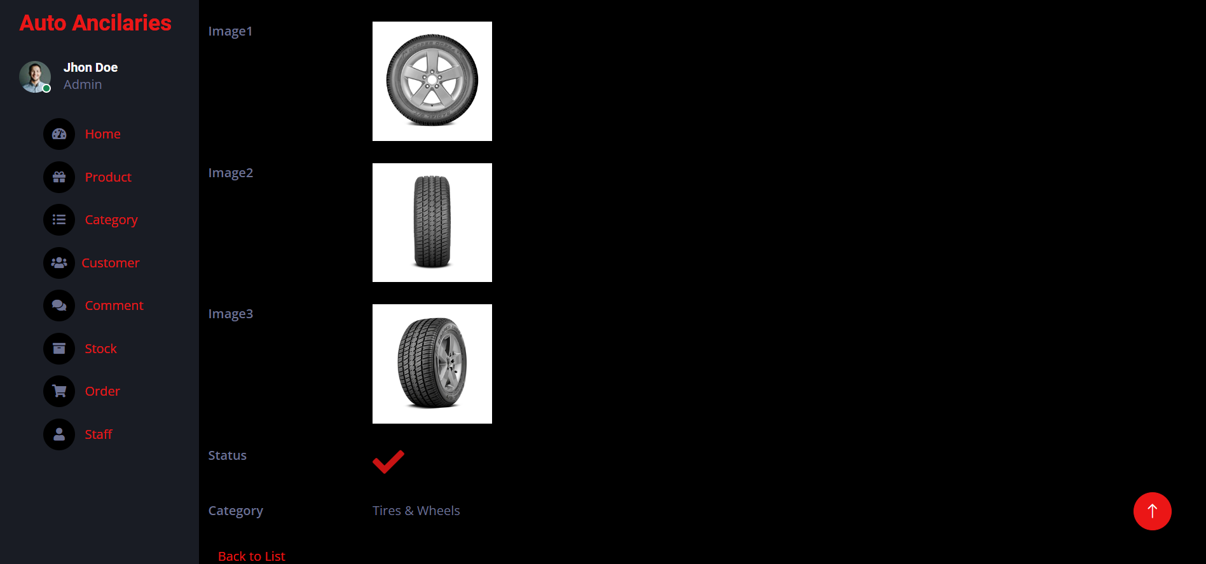

|  |  |  |  |  |  |  |
| --- | --- | --- | --- | --- | --- | --- |
| **No** | **Name** | **Type** | **Validation** | **Event** | **Description** | **Status** |
| 1 | ProductName |  |  |  | Display product name | Enable |
| 2 | Rate |  |  |  | Display product rate | Enable |
| 3 | Price |  |  |  | Display product price | Enable |
| 4 | Description |  |  |  | Display product description | Enable |
| 5 | Avatar |  |  |  | Display product avatar | Enable |
| 6 | Image1 |  |  |  | Display product image1 | Enable |
| 7 | Image2 |  |  |  | Display product image2 | Enable |
| 8 | Image3 |  |  |  | Display product image3 | Enable |
| 9 | CategoryId |  |  |  | Display category | Enable |
| 10 | Active or Unactive |  |  |  | Display active or unactive | Enable |
| 11 | Back to list | Hyperlink |  | Click | Return list product page | Enable |

## Admin manage delete Product

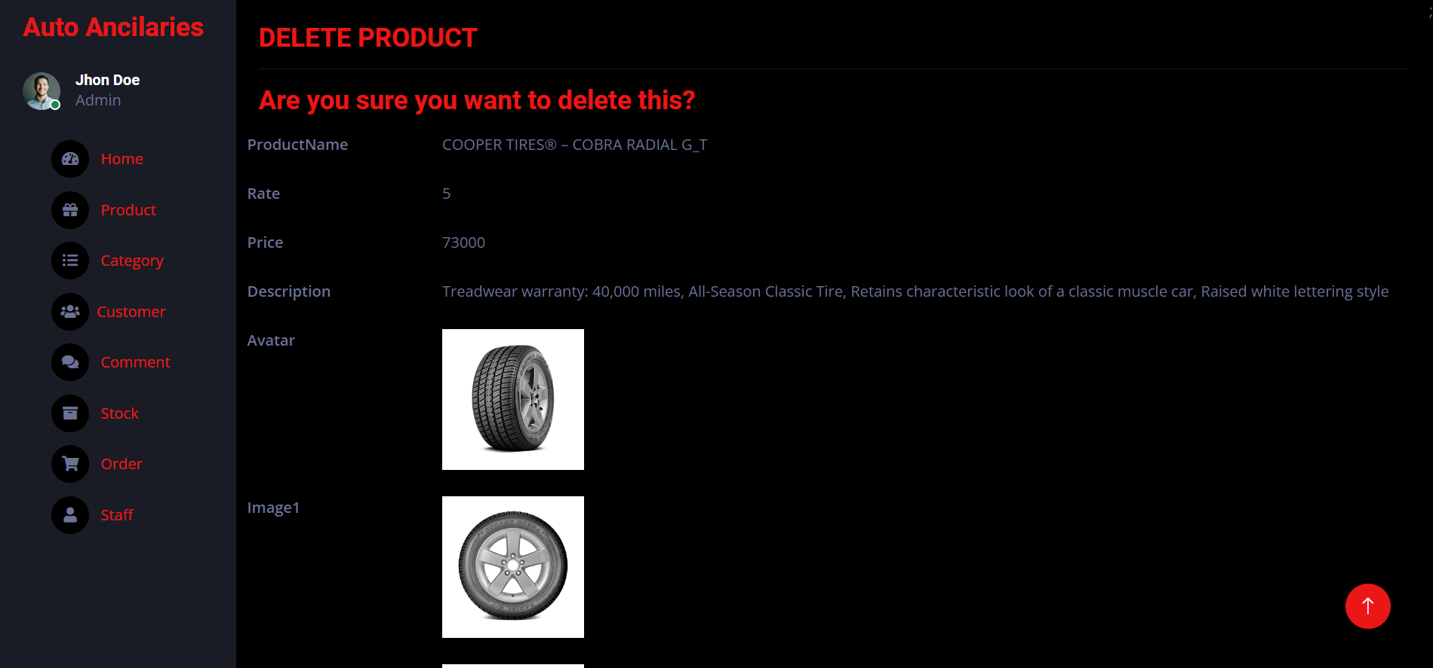

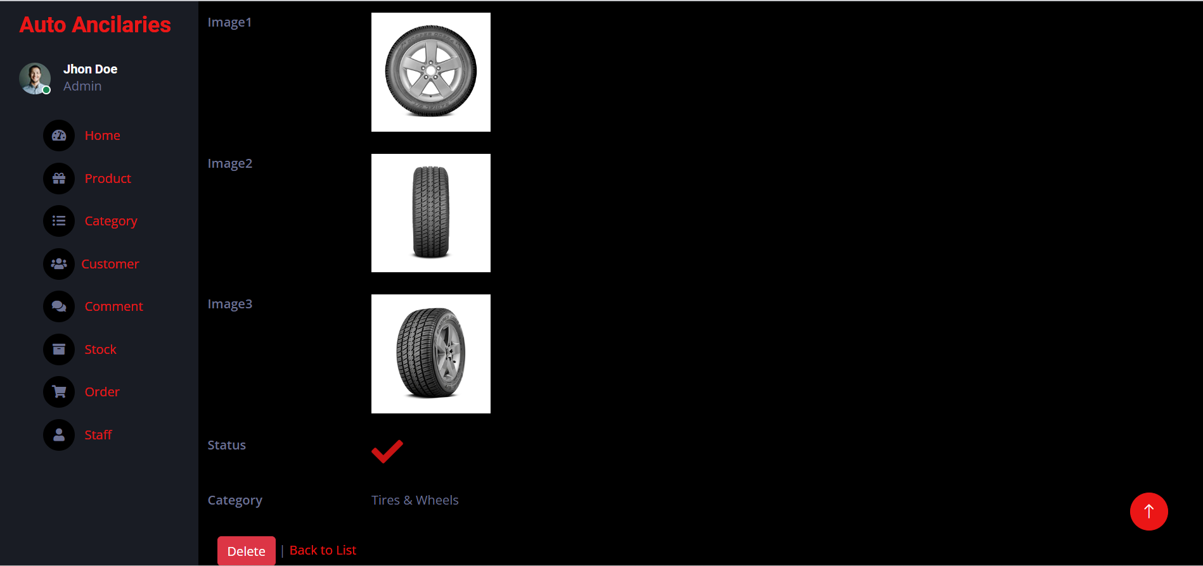

|  |  |  |  |  |  |  |
| --- | --- | --- | --- | --- | --- | --- |
| **No** | **Name** | **Type** | **Validation** | **Event** | **Description** | **Status** |
| 1 | Delete | Button |  |  | Delete product | Enable |
| 2 | Back to list | Hyperlink |  | Click | Return list page | Enable |

## Admin manage List Category

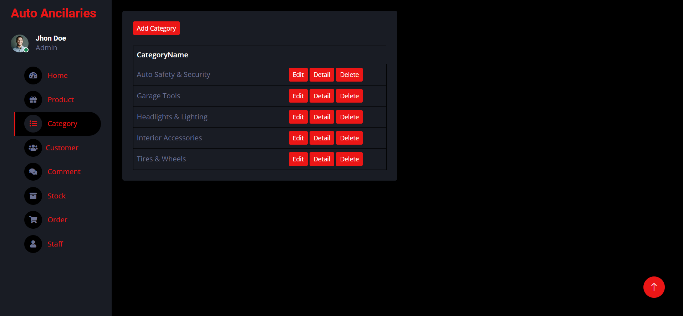

|  |  |  |  |  |  |  |
| --- | --- | --- | --- | --- | --- | --- |
| **No** | **Name** | **Type** | **Validation** | **Event** | **Description** | **Status** |
| 1 | Add Category | Button |  |  | Add new Category | Enable |
| 2 | Edit | Button |  |  | Eidt category | Enable |
| 3 | Detail | Button |  |  | Display detail category | Enable |
| 4 | Delete | Button |  |  | Delete category | Enable |

## Admin manage Add Category

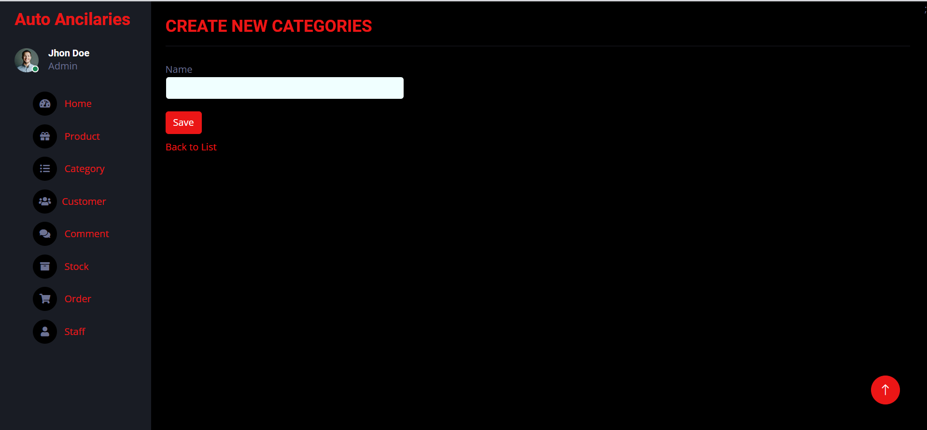

|  |  |  |  |  |  |  |
| --- | --- | --- | --- | --- | --- | --- |
| **No** | **Name** | **Type** | **Validation** | **Event** | **Description** | **Status** |
| 1 | Name | Input | Required |  | Insert category name | Enable |
| 2 | Save | Button |  |  | Submit create category | Enable |
| 3 | Back to list | Hyperlink |  | Click | Return list category page | Enable |

## Admin manage Edit Category

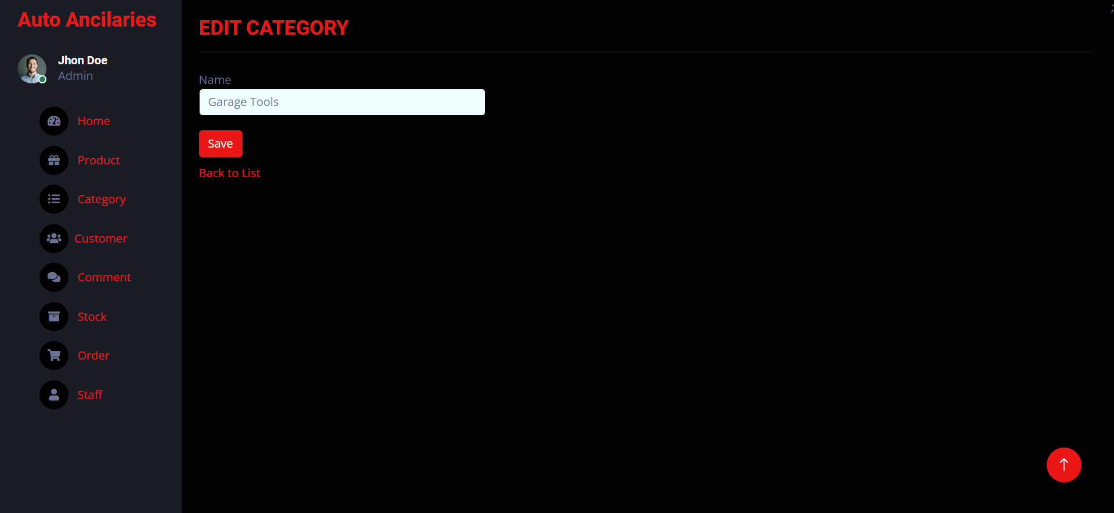

|  |  |  |  |  |  |  |
| --- | --- | --- | --- | --- | --- | --- |
| **No** | **Name** | **Type** | **Validation** | **Event** | **Description** | **Status** |
| 1 | Name | Input | Required |  | Edit category name | Enable |
| 2 | Save | Button |  |  | Submit edit category | Enable |
| 3 | Back to list | Hyperlink |  | Click | Return list category page | Enable |

## Admin manage Detail Category

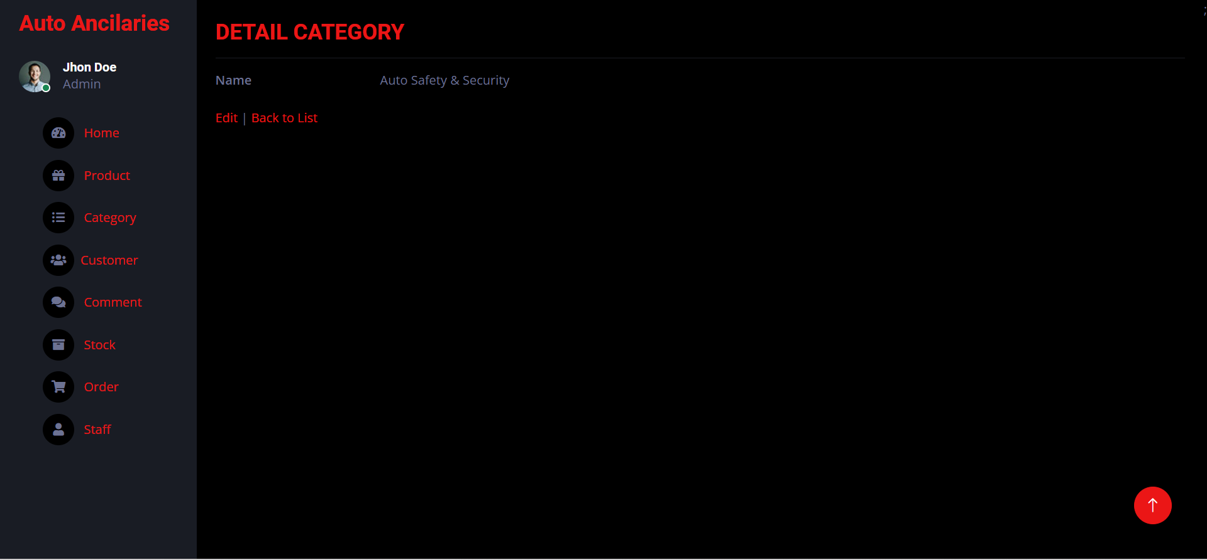

|  |  |  |  |  |  |  |
| --- | --- | --- | --- | --- | --- | --- |
| **No** | **Name** | **Type** | **Validation** | **Event** | **Description** | **Status** |
| 1 | Name |  |  |  | Display category name | Enable |
| 2 | Back to list | Hyperlink |  | Click | Return list category page | Enable |

## Admin manage Delete Category

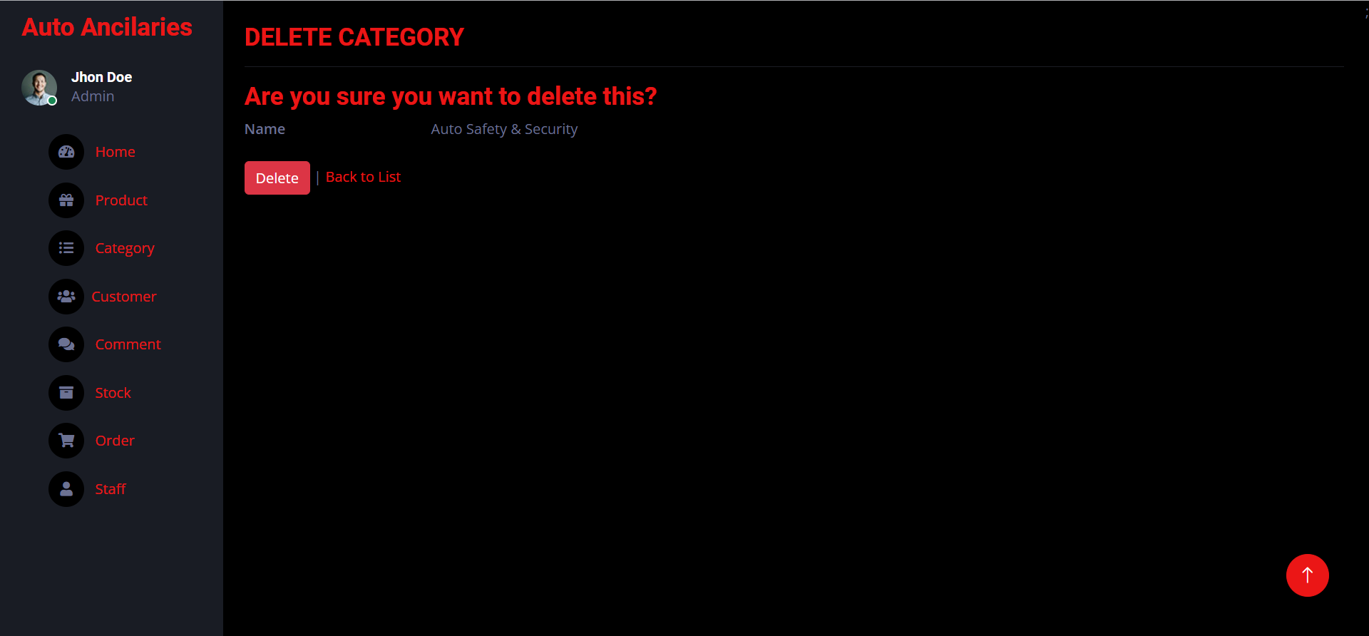

|  |  |  |  |  |  |  |
| --- | --- | --- | --- | --- | --- | --- |
| **No** | **Name** | **Type** | **Validation** | **Event** | **Description** | **Status** |
| 1 | Delete | Button |  |  | Delete category | Enable |
| 2 | Back to list | Hyperlink |  | Click | Return list category page | Enable |

## Admin manage Customer

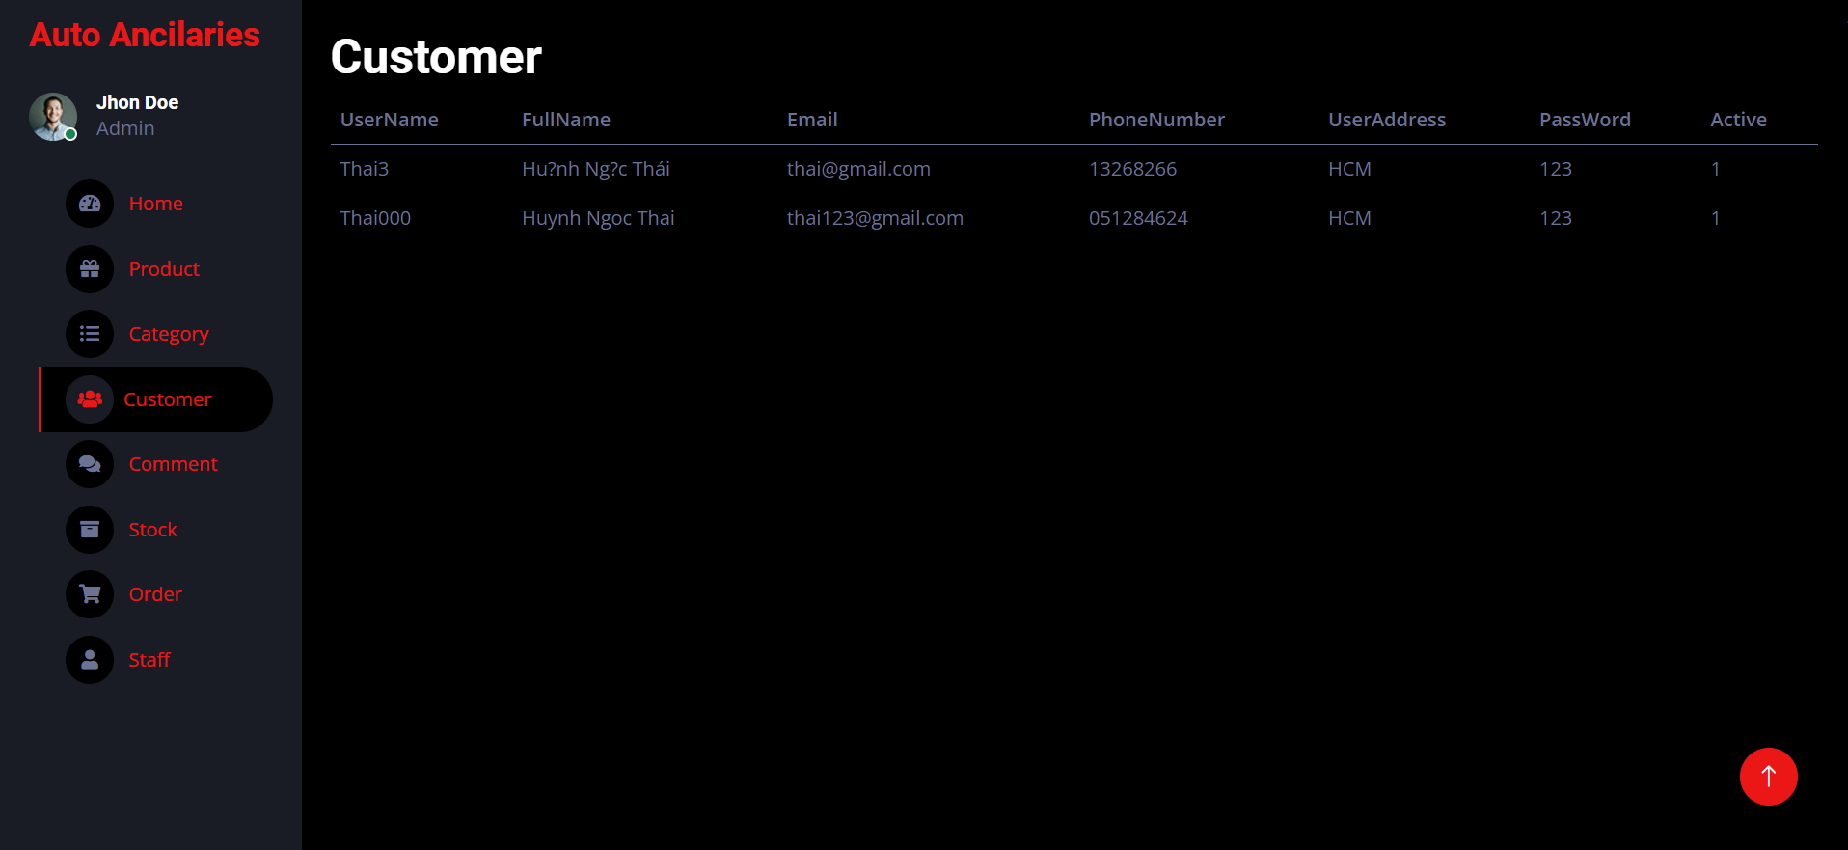

|  |  |  |  |  |  |  |
| --- | --- | --- | --- | --- | --- | --- |
| **No** | **Name** | **Type** | **Validation** | **Event** | **Description** | **Status** |
| 1 | Customer |  |  |  | Display list customer | Enable |

## Admin manage Comment

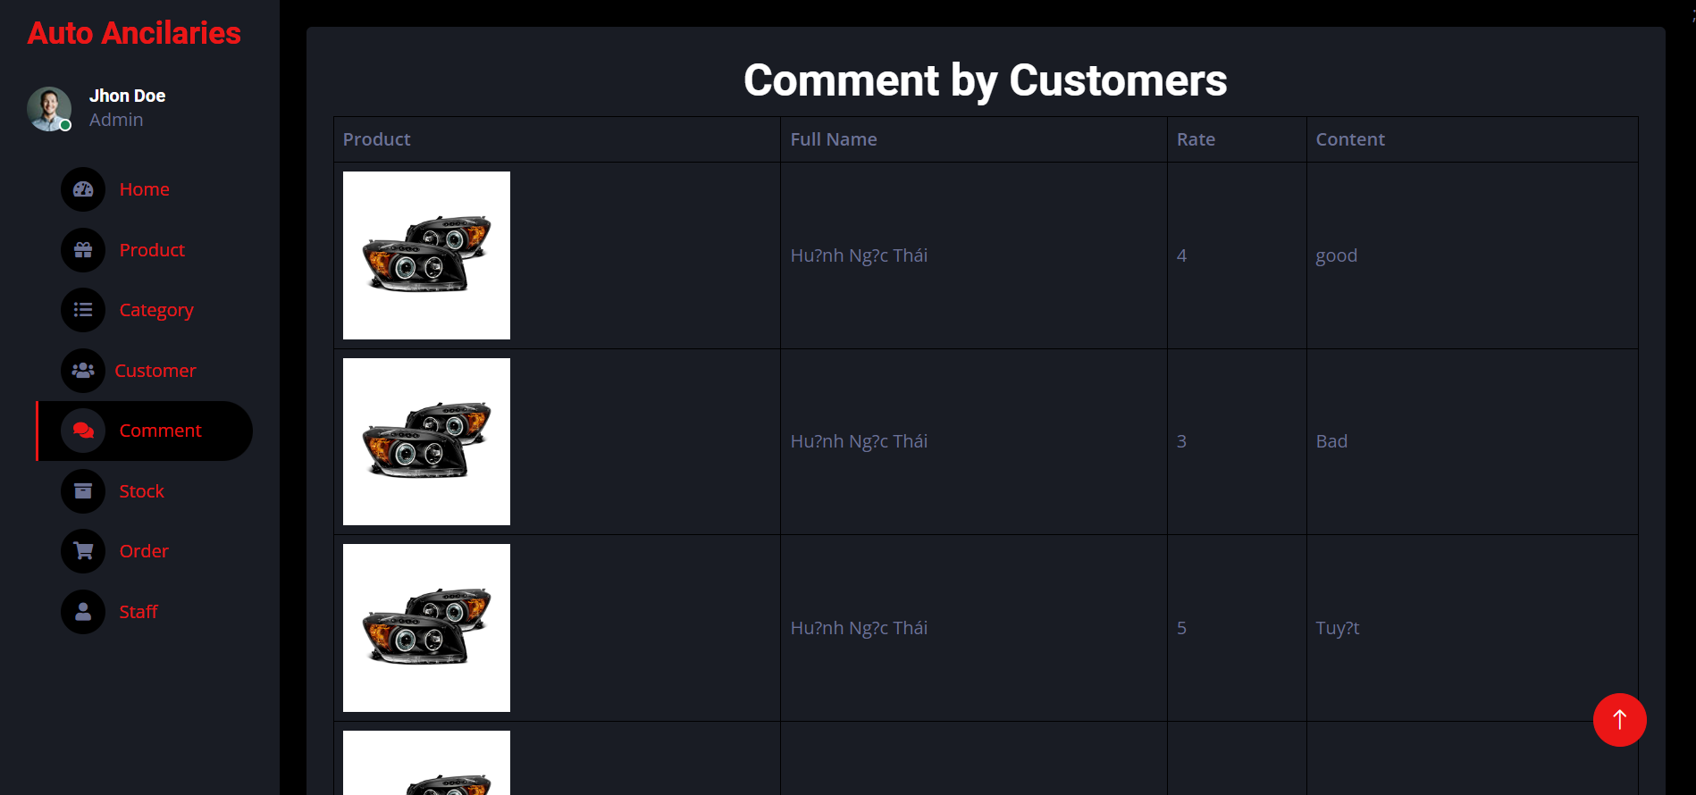

|  |  |  |  |  |  |  |
| --- | --- | --- | --- | --- | --- | --- |
| **No** | **Name** | **Type** | **Validation** | **Event** | **Description** | **Status** |
| 1 | Comment |  |  |  | Display list comment | Enable |

## Admin manage Stock

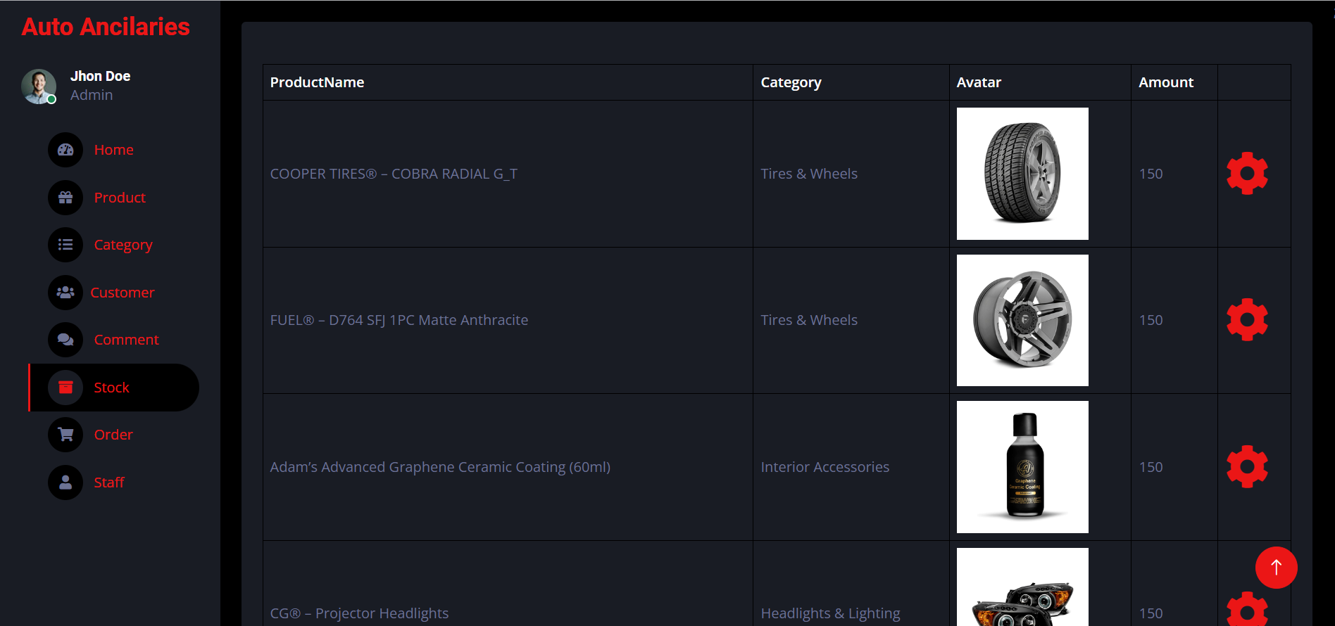

|  |  |  |  |  |  |  |
| --- | --- | --- | --- | --- | --- | --- |
| **No** | **Name** | **Type** | **Validation** | **Event** | **Description** | **Status** |
| 1 | Stock |  |  |  | Display list Stock | Enable |